**Adding Users**

Companies will have many different projects with many different users working on them. And those users will often have different needs.

For example, some users might need access to every project, while others might only need to access one or two. Some users will just need the ability to just look at things, while others might also need to make changes. That is why every project in your Google Cloud Platform account has its own set of users. And each user account can have its own unique set of permissions.

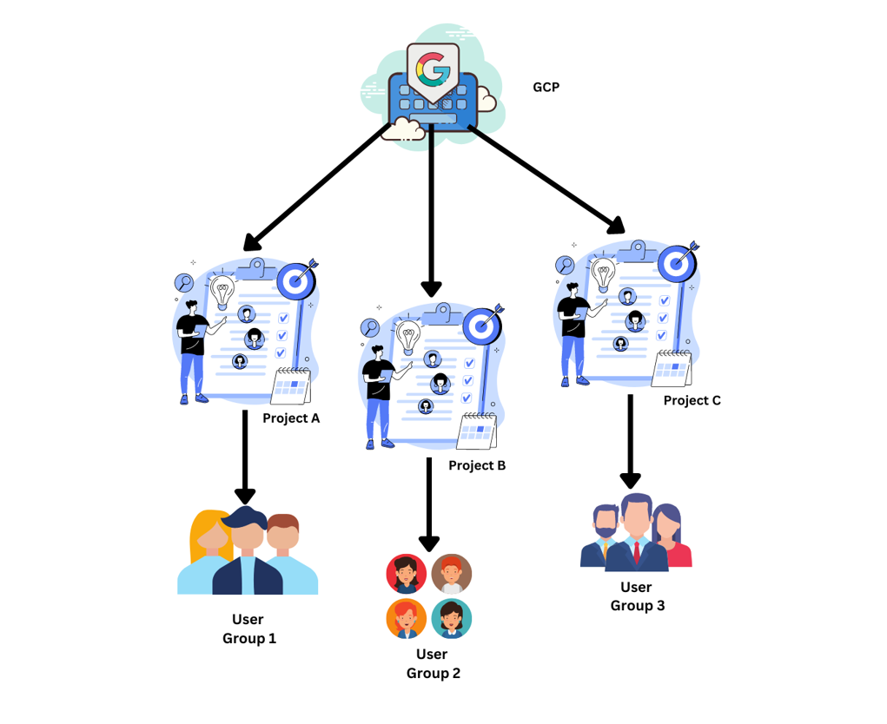

**Creating Accounts Manually:**

* New user accounts can be created manually.
* Only recommended for a small number of users.

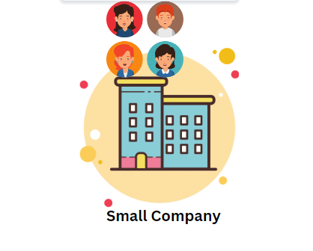

**Creating Accounts Using Google Cloud Identity:**

* Recommended for larger companies.
* Google Cloud Identity allows us to sync user accounts across.

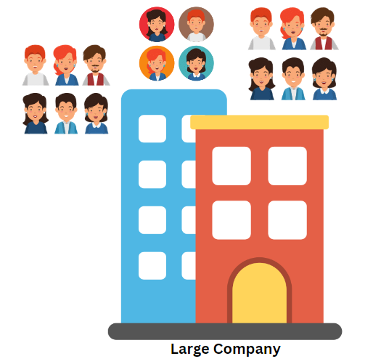

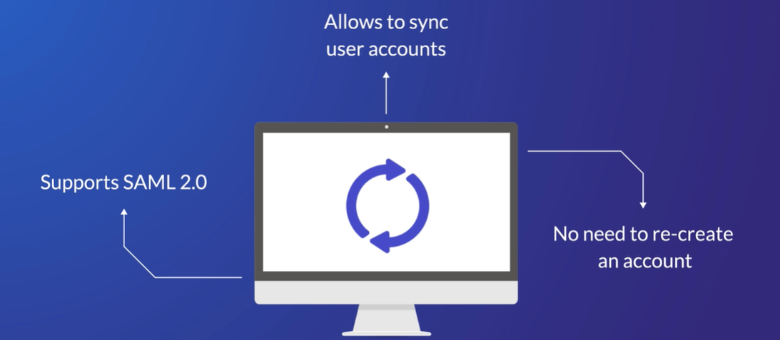

Google Cloud Identity

**Adding Users:**

1. Once you first log in, your screen should look similar to this.

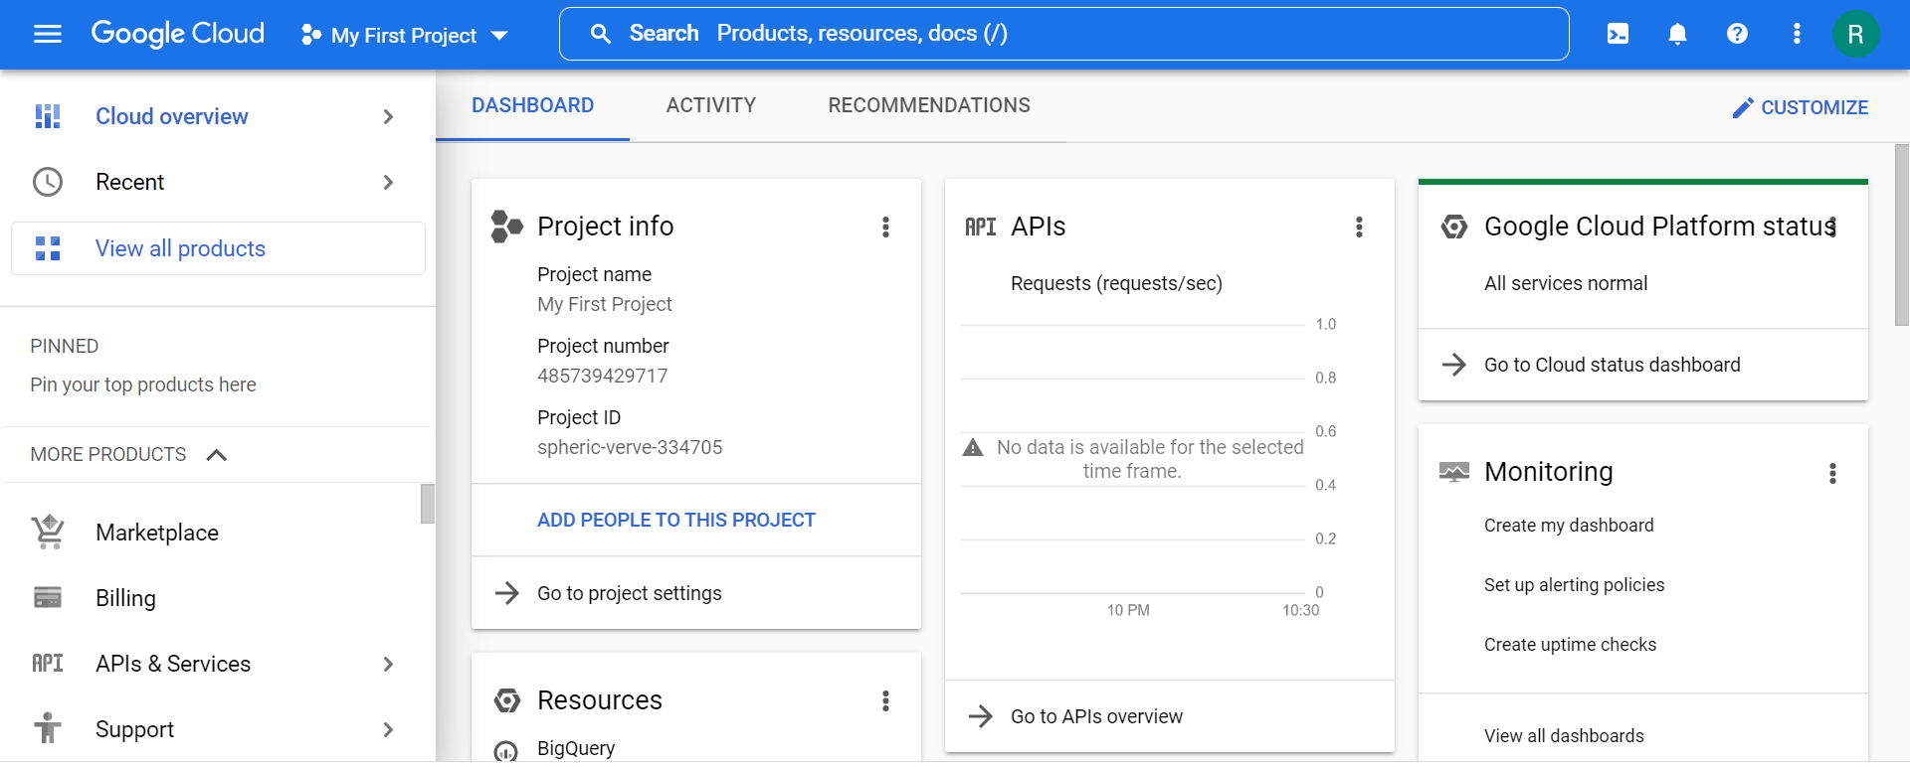

1. Click on the project selector drop-down menu at the top of the screen.

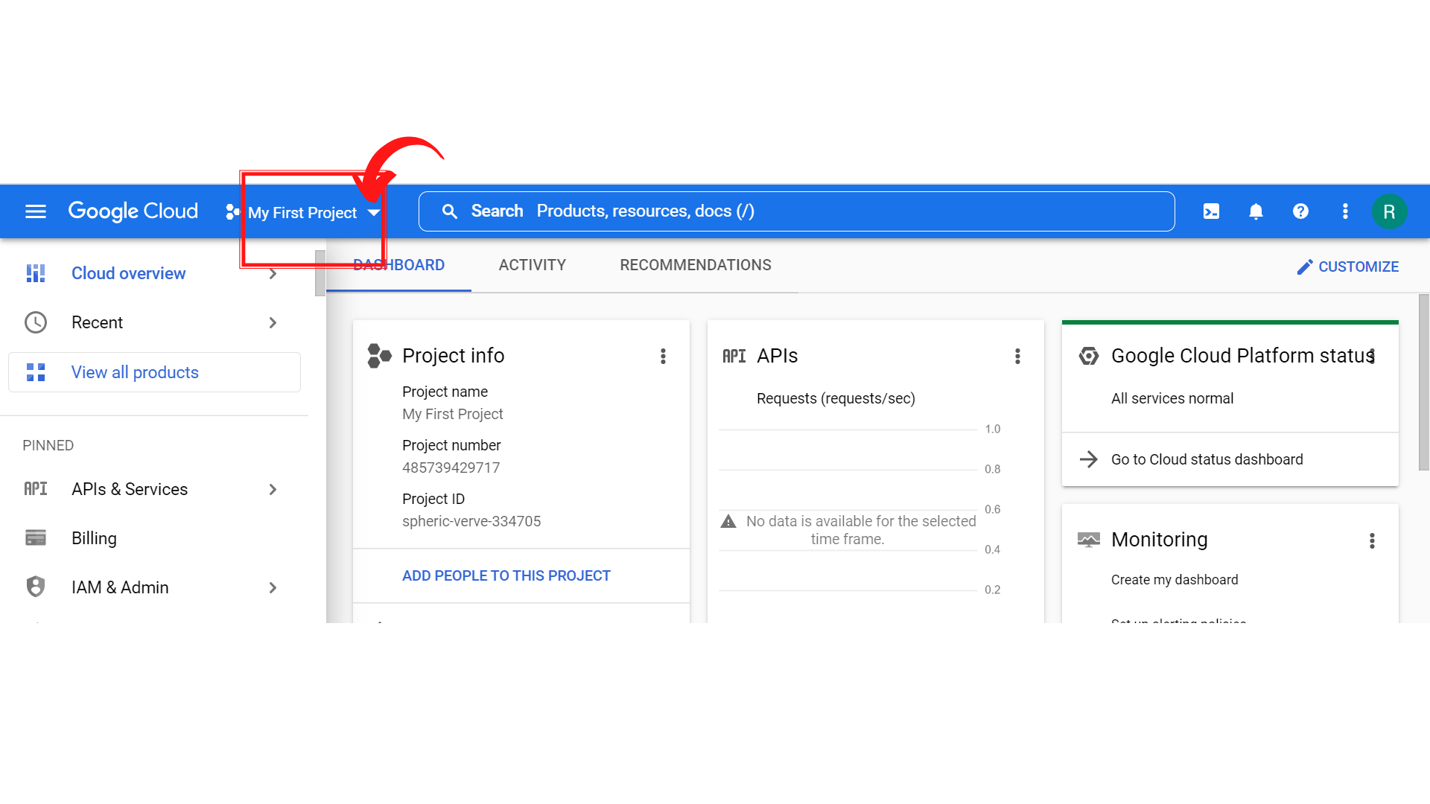

1. Since, we are doing labs on a Security Labs project, Click on *“Security Labs”*.

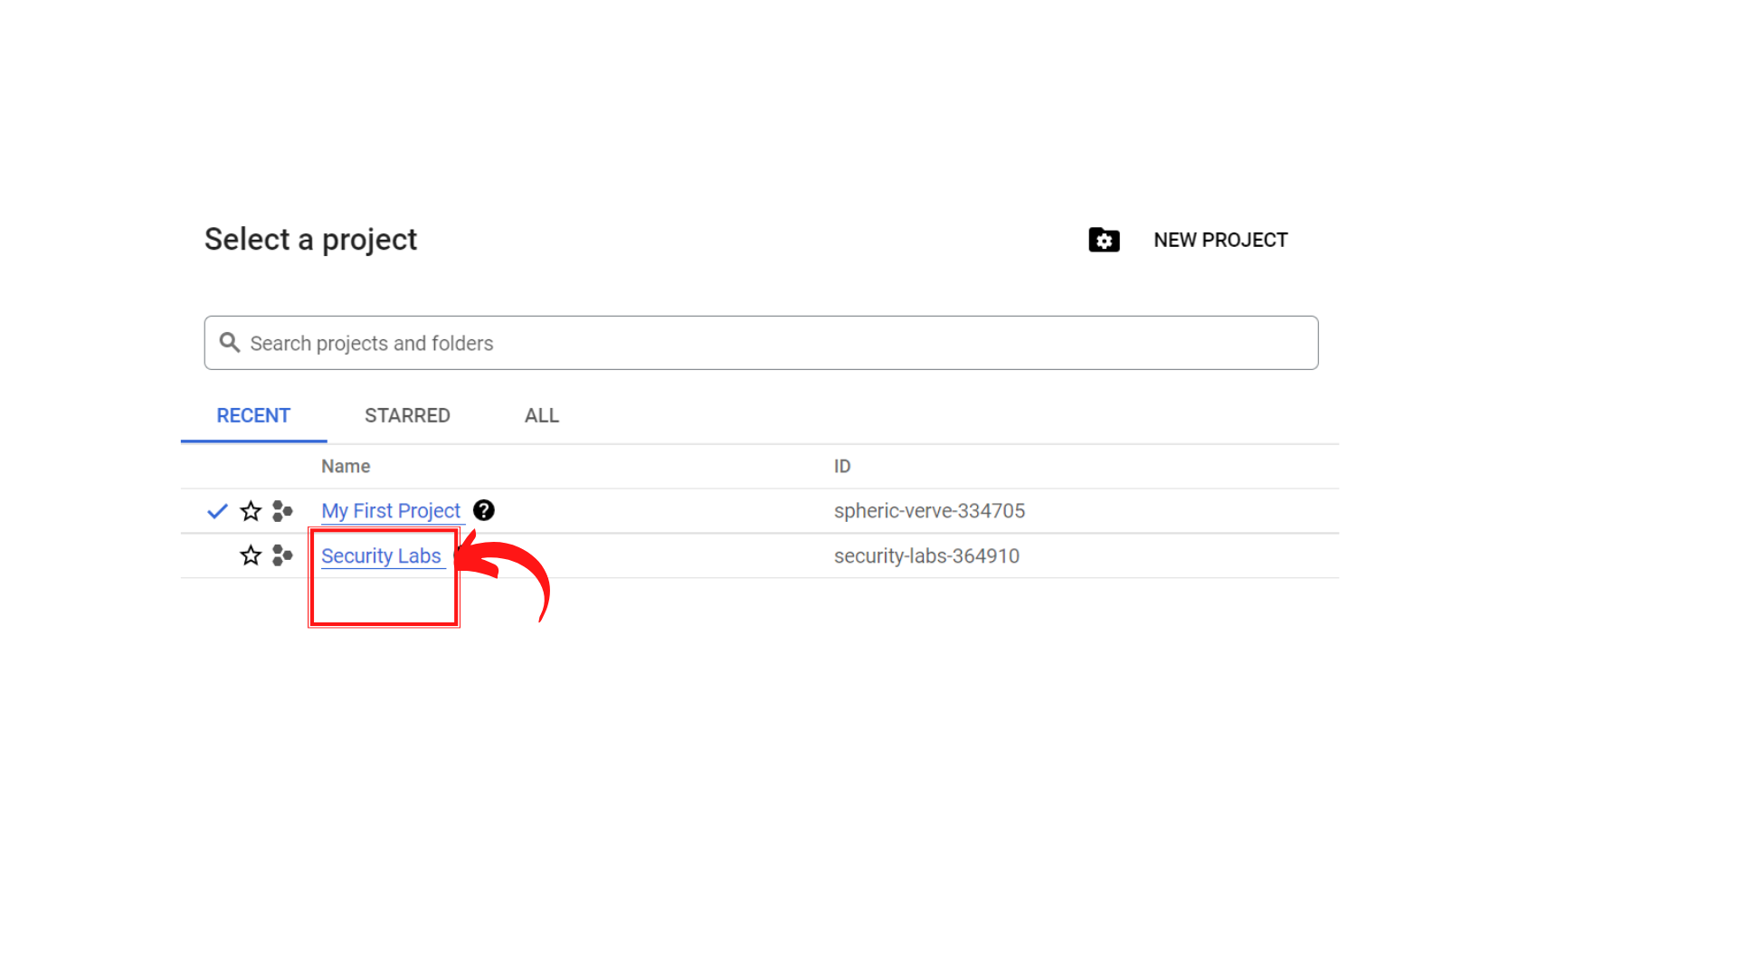

1. Your screen should look similar to this with project info changed to “*Security Labs”* project.

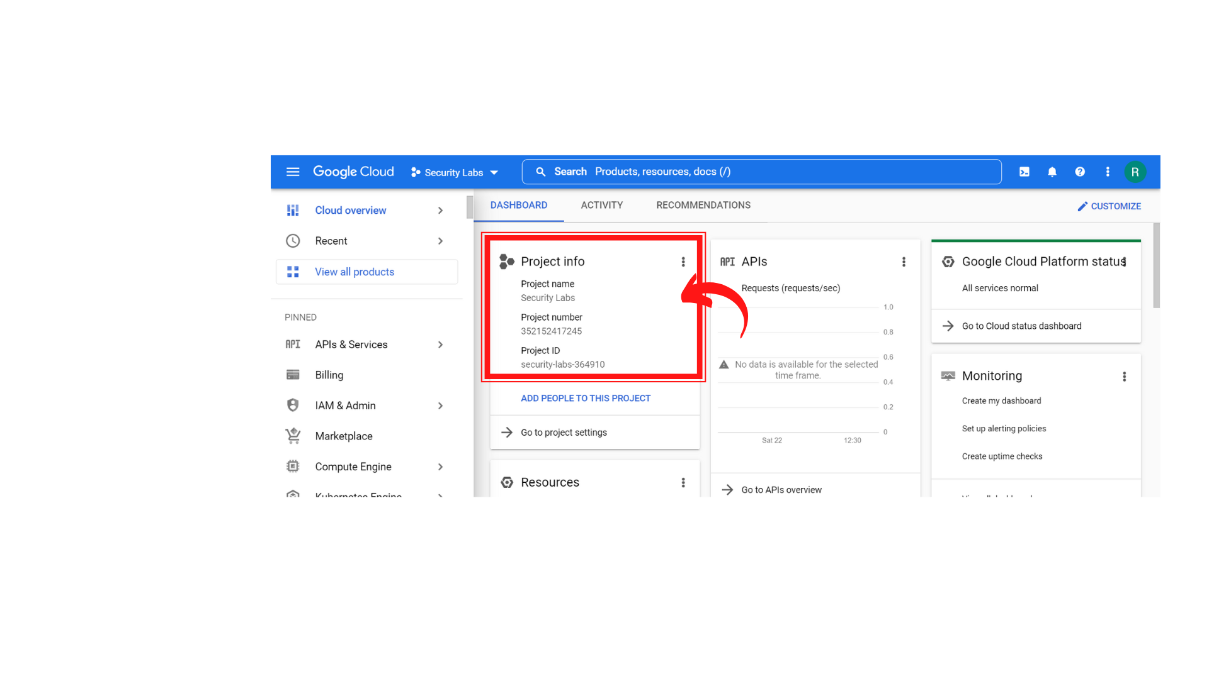

1. To add new users, click on *“IAM & Admin” → IAM”.*

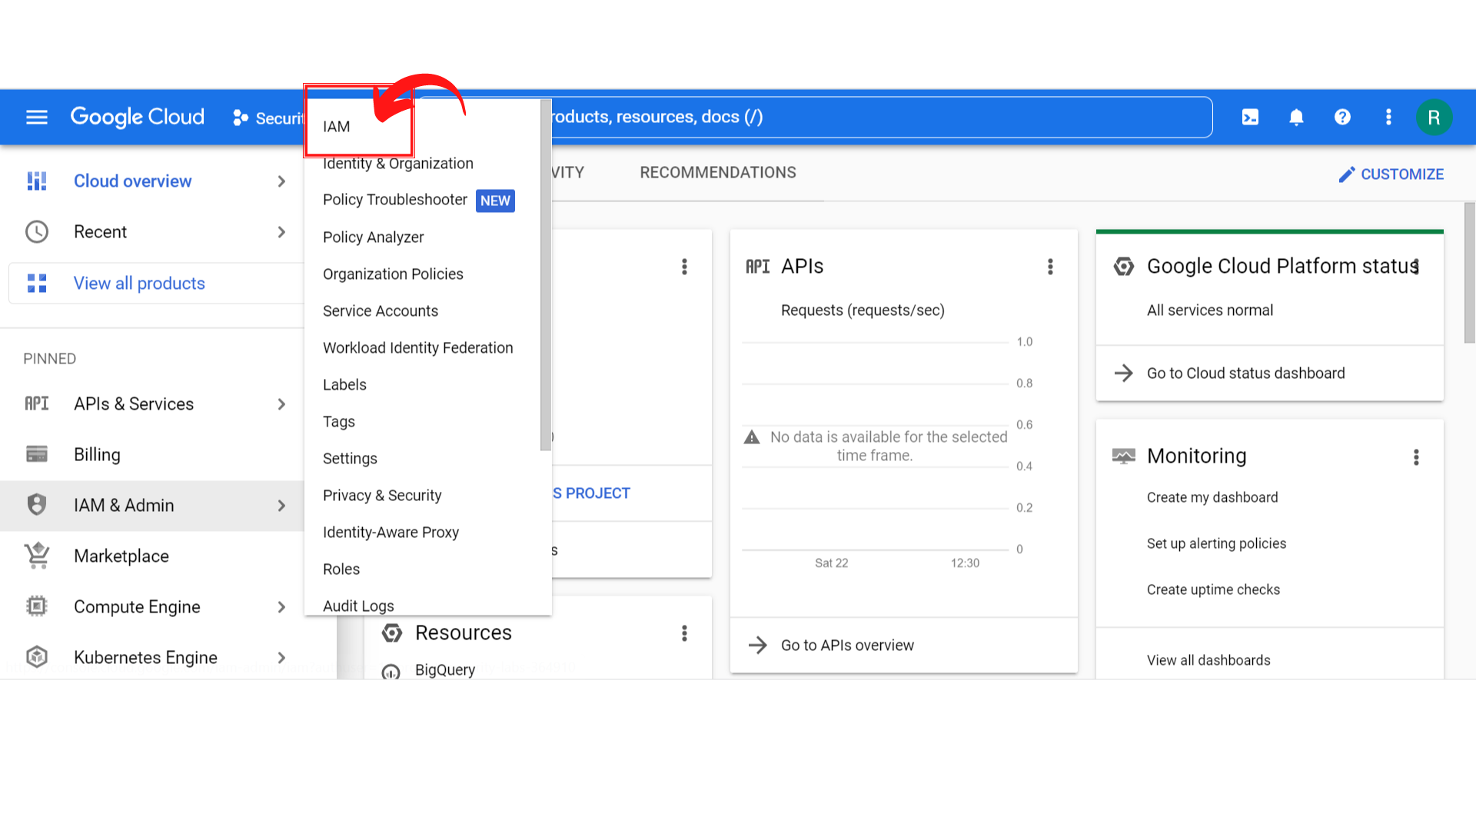

1. Your screen should look similar to this.

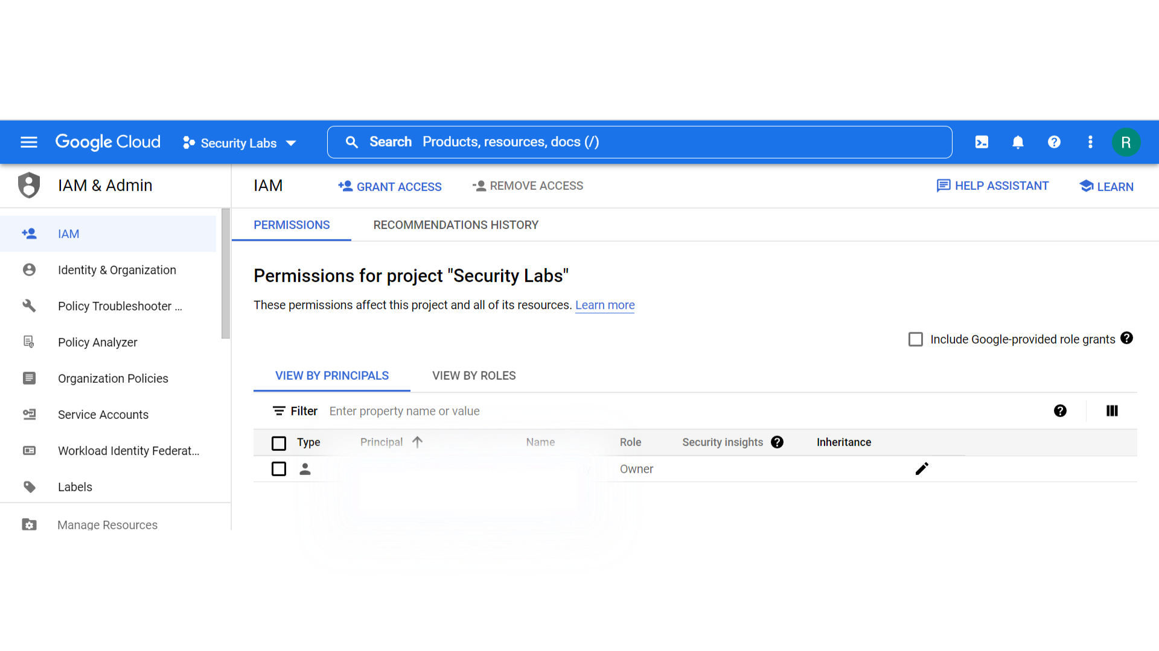

1. Right now, single user in your account because you haven’t added any user in this project.

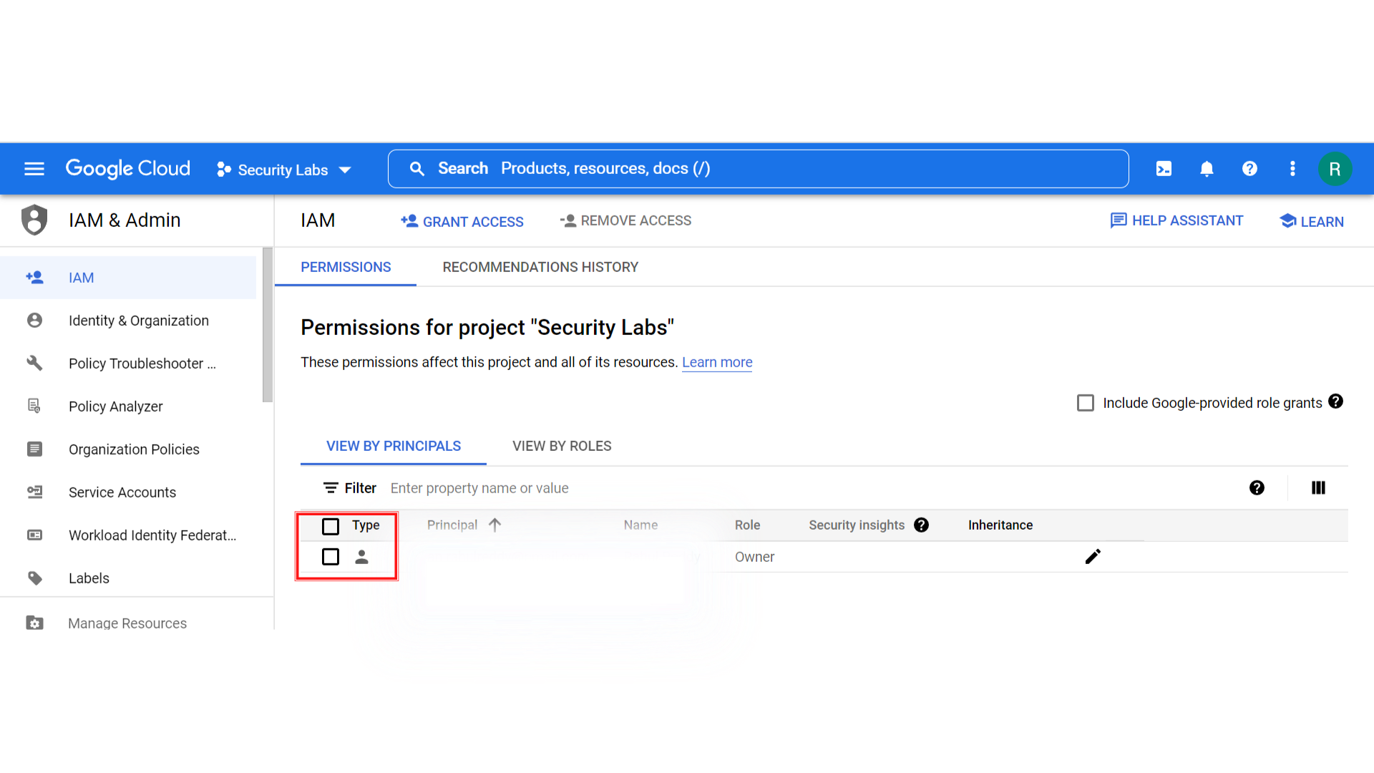

1. To add users to the project, click on “*Grant access”* on the top menu.

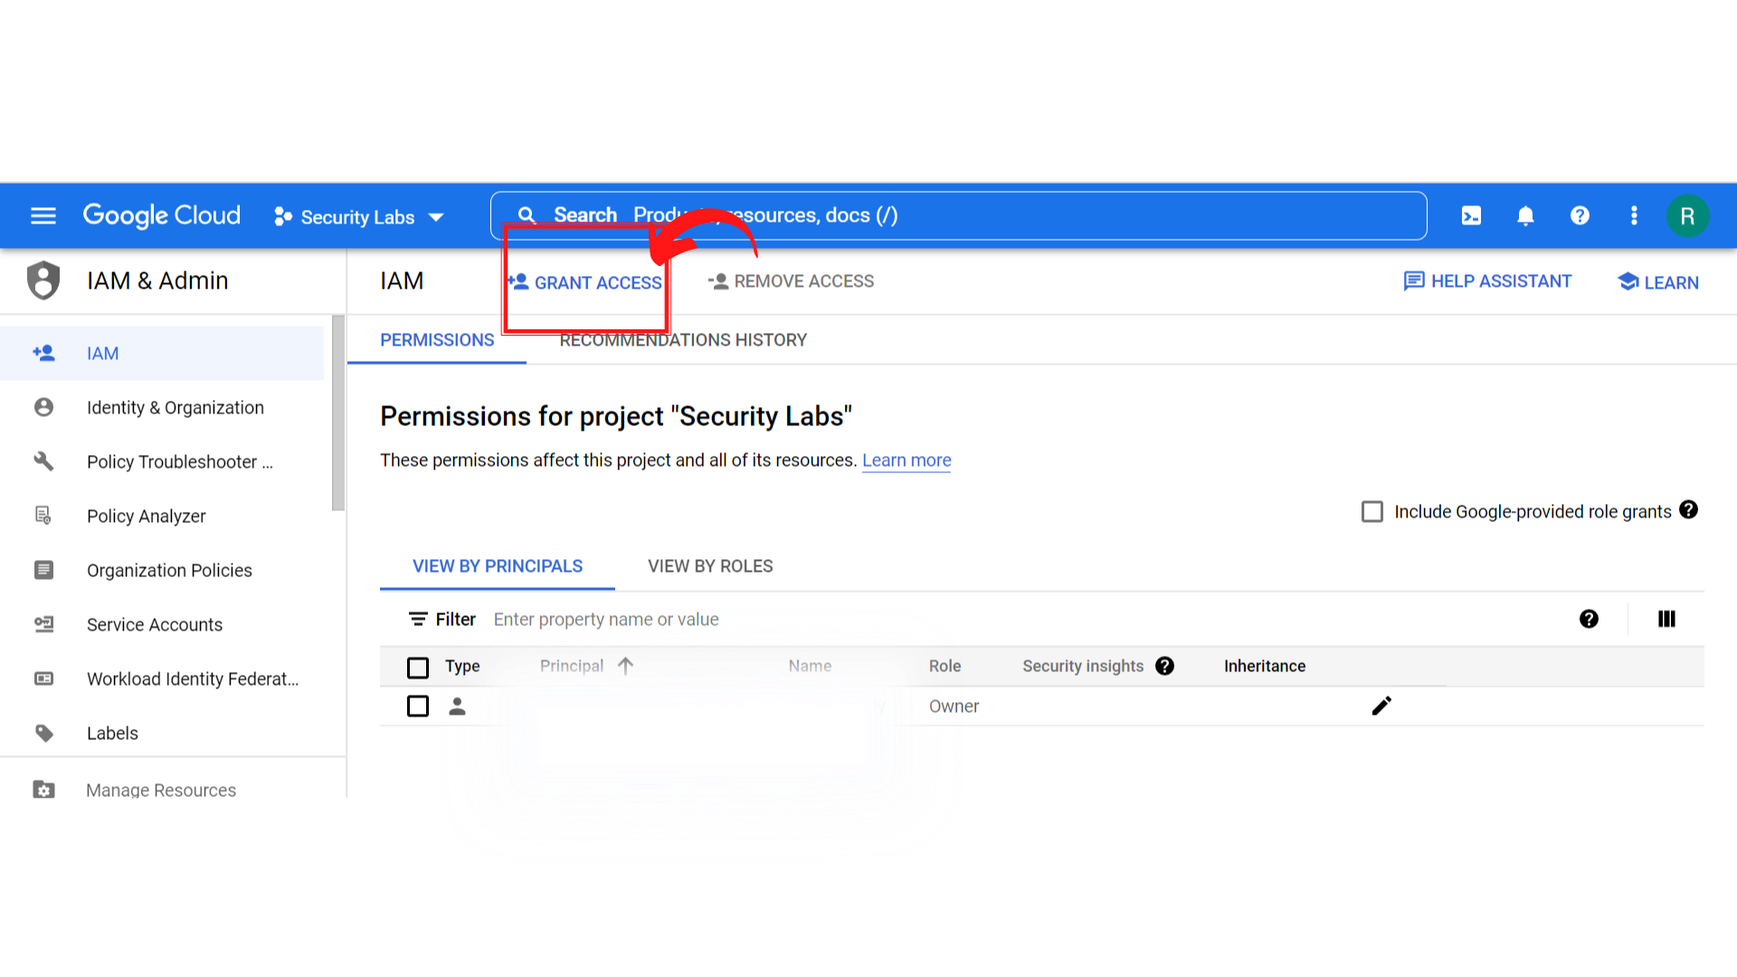

1. Your screen should look similar to this.

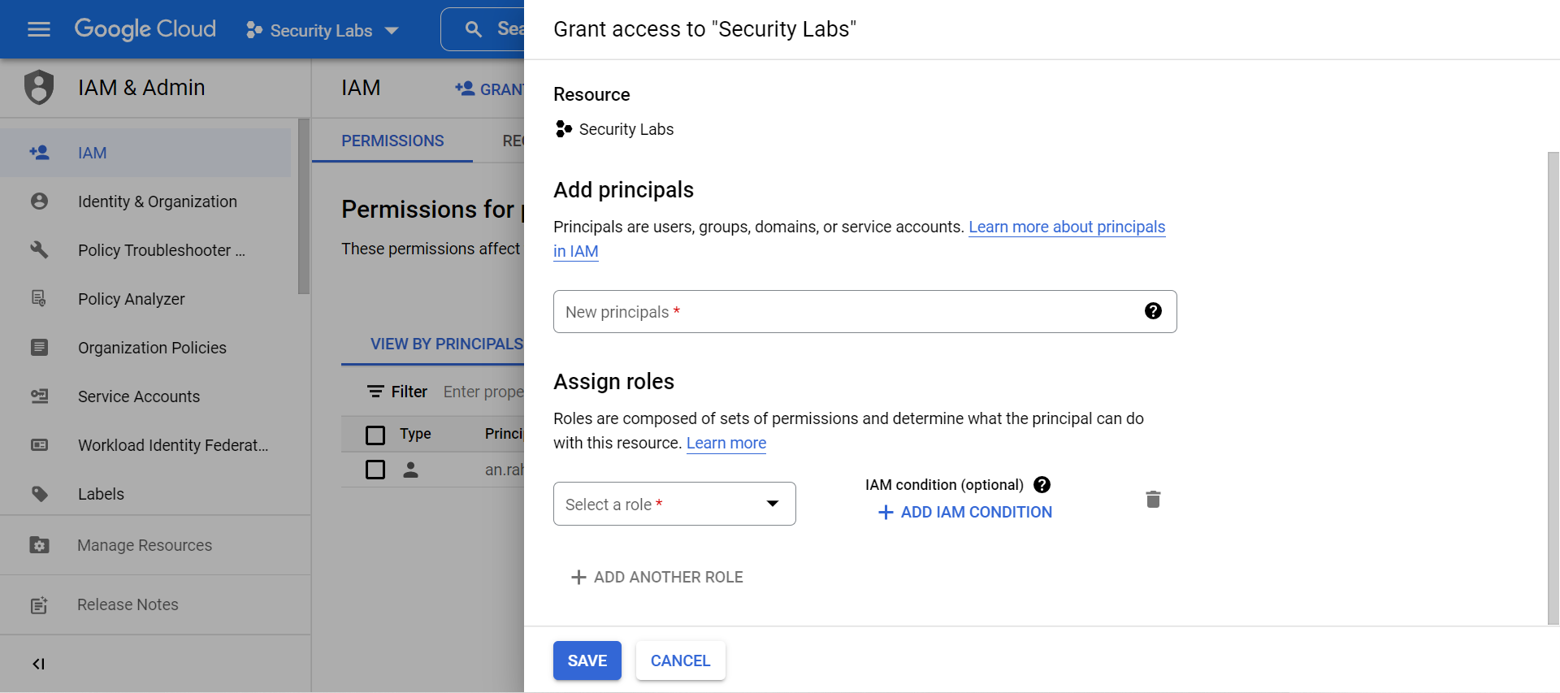

1. You can add the user Email ID of the user who you want to give access in the *”New Principals”* block.

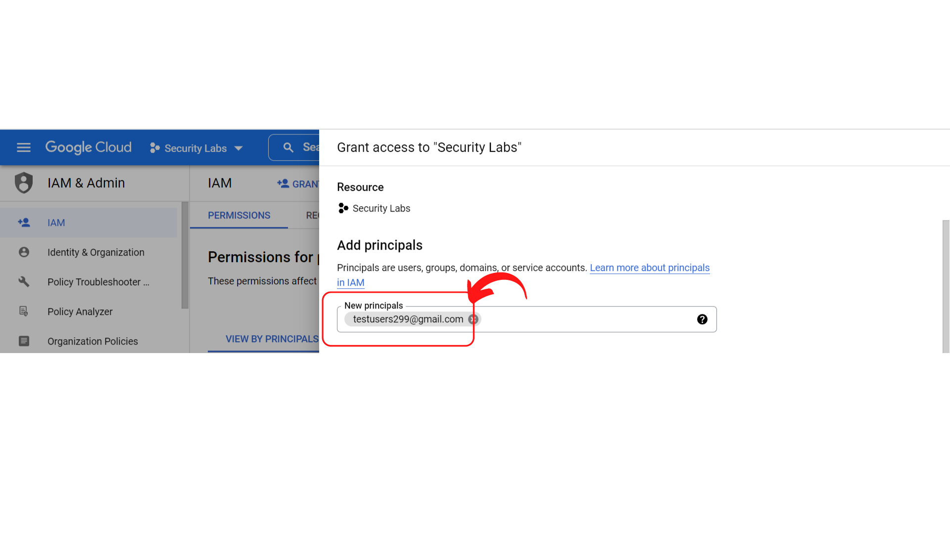

1. Then you need to assign roles based on your requirements. Here I’m selecting the *“Basic → Browser”* role.

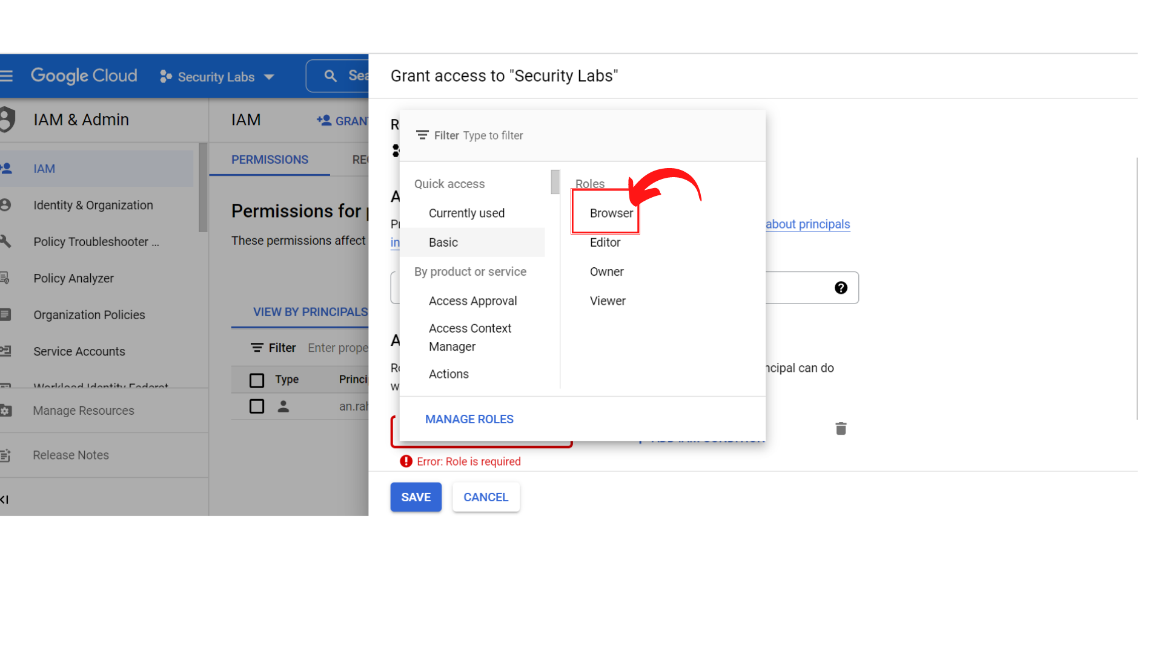

1. Your screen should look similar to this and click on *“Save”.*

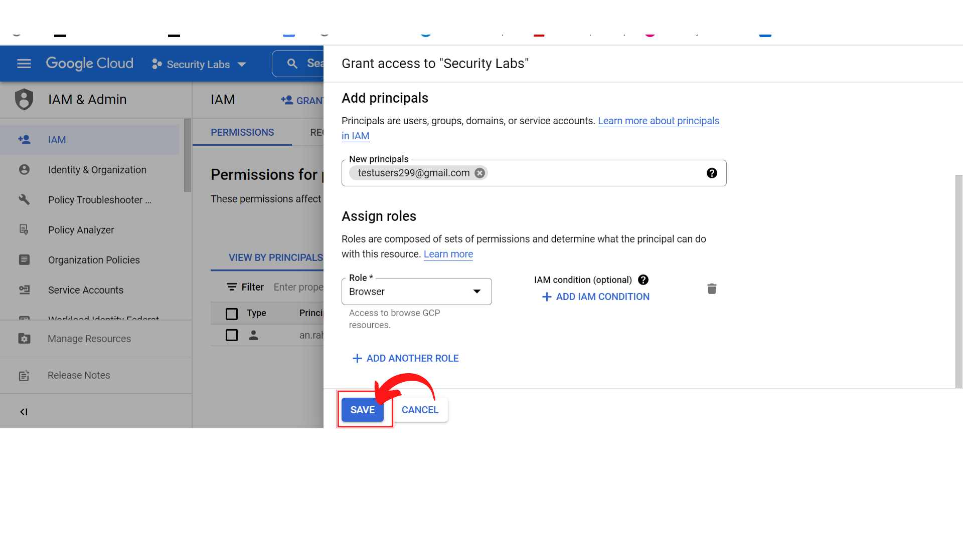

Note: Principals are users, groups, domains, or service accounts. To learn more about [Principals IAM](https://cloud.google.com/iam/docs/overview?authuser=1&_ga=2.165636607.-1786241431.1659241335&_gac=1.192993759.1665448318.Cj0KCQjwhY-aBhCUARIsALNIC04-CPHIpgCHh3TEy9s3YWfw5suofgLpDZDfcJm4zZp-e8COpkOPb48aAgOqEALw_wcB#concepts_related_identity).

1. Now, you can see the user added to the project with Basic Role → Browser.

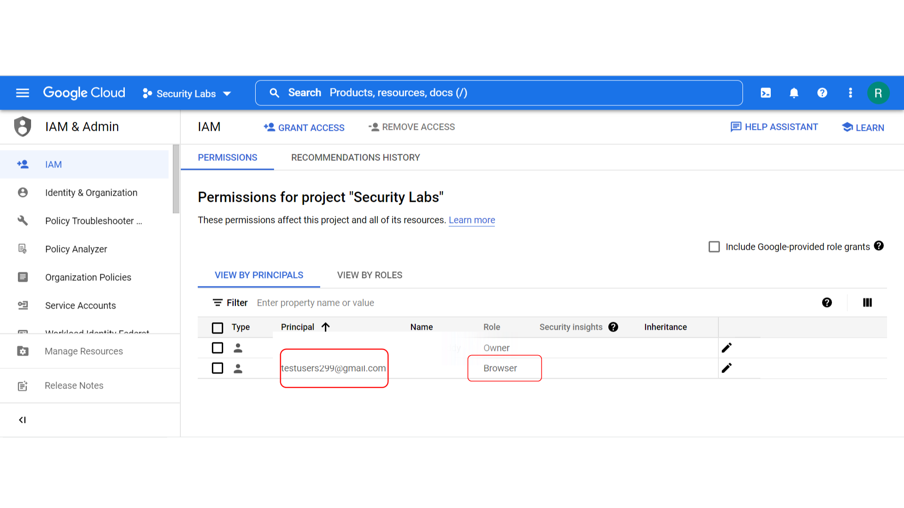

1. Successfully, you have added a new user with an assigned role.
2. Now you can remove the user from the project, if the user is no longer required to the project by clicking on the tick box.

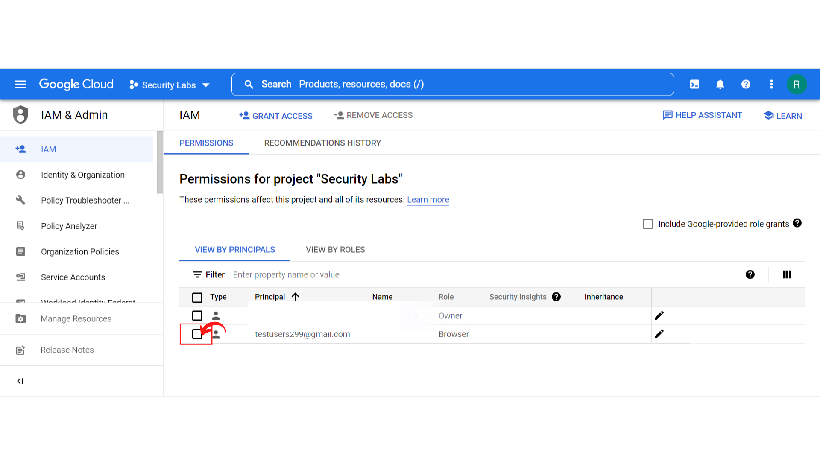

1. Your screen should look similar to this and click on *“Remove Access”.*

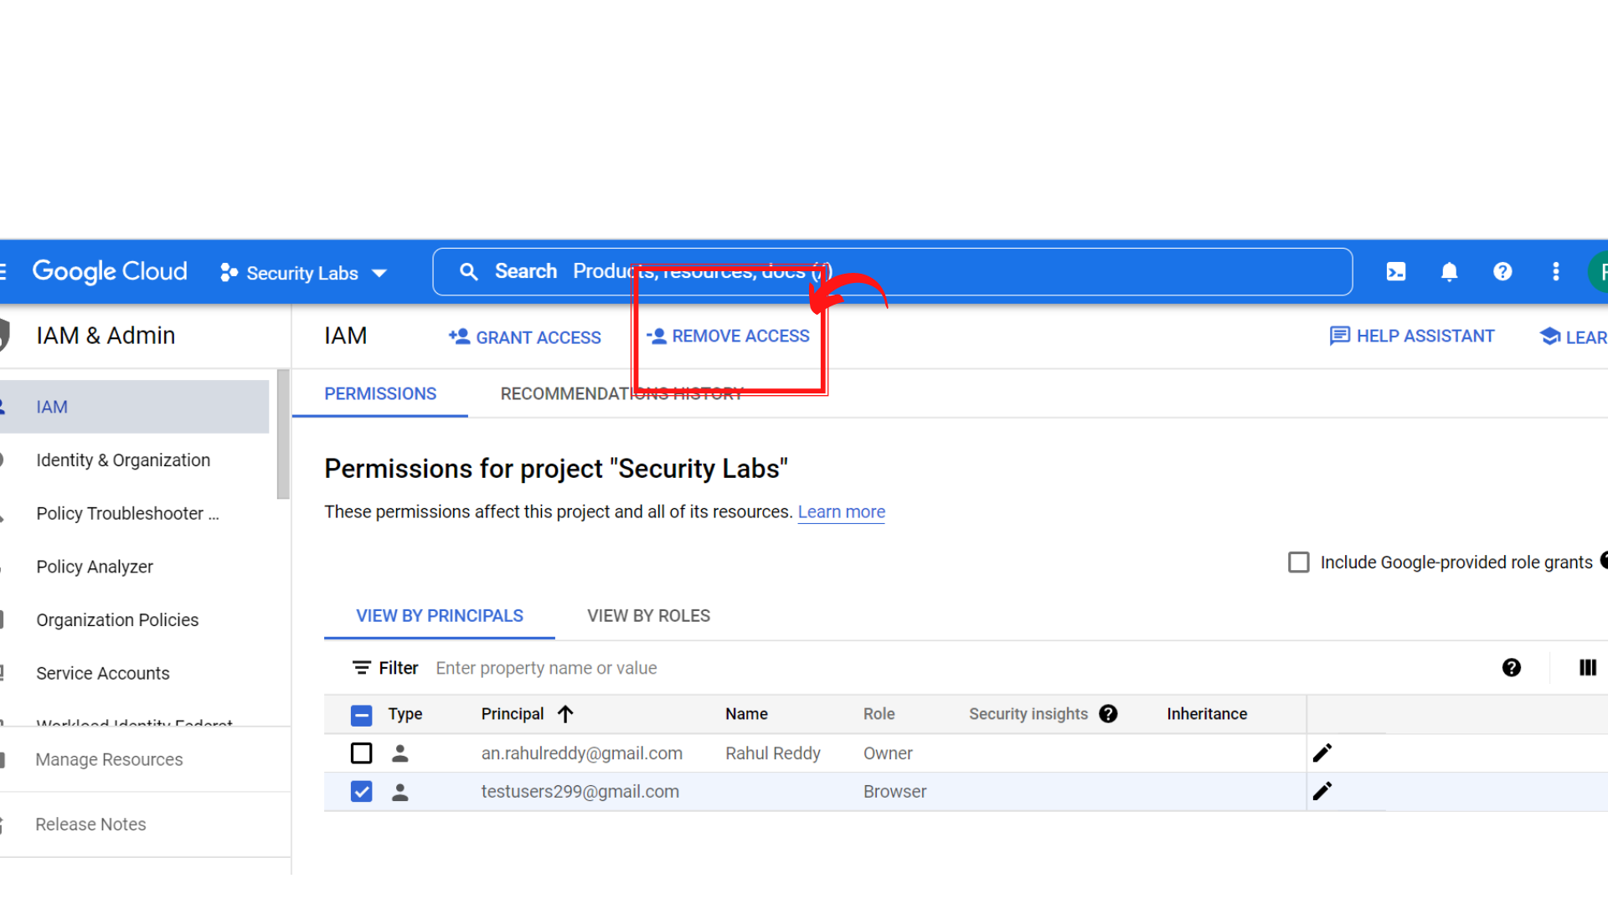

1. A pop-up will be displayed to confirm your action to remove the user, click on “*Confirm”* to remove the user.
2. That’s it, you have successfully removed the user from the project.